EXPERIMENT – 3
JOB APPLICATION FORM USING ZOHO CREATOR

NAME : KAMALI RJ
REGISTER : 240701225

AIM
To design and develop a Job Application Form using Zoho Creator by using different Basic Fields to collect candidate details, job preferences, skills, experience, interview availability, cover letter, and background verification consent.

OBJECTIVE
The main objective is to create a simple and structured online job application form for collecting and managing candidate information. The form helps HR collect personal details, contact information, job preferences, experience, skills, joining date, interview time, cover letter, and consent for background verification.

JOB APPLICATION FORM
The application was created in Zoho Creator with the form name Job_Application_Form.

Section A – Personal Details: Candidate Name, Current Address, Contact Number.
Section B – Contact & Online Presence: Email Address, LinkedIn / Portfolio.
Section C – Job & Experience Details: Department Applied For, Employment Type Preferred, Years of Experience, Key Skills, Available Joining Date.
Section D – Interview Scheduling & Consent: Preferred Interview Time, Cover Letter, Background Verification Consent.

BASIC FIELDS USED

Name | Candidate_Firstname | Stores candidate's first and last name
Email | Email_Address | Collects candidate's email address
Address | Current_Address Contact_Number | Stores complete residential address
Phone | LinkedIn_Profile | Collects candidate's mobile number
Single Line | Cover_Letter | Stores LinkedIn or portfolio URL
Multi Line | Years_Of_Experience | Collects remarks about why the candidate is suitable
Number | Available_Joining_Date | Stores years of professional experience
Date | Preferred_Interview_Time | Stores earliest joining date
Time | Department_Applied_For | Stores preferred interview time
Drop Down | Employment_Type_Preferred | Allows selection of department
Radio | Key_Skills | Selects Full-Time, Part-Time or Internship
Multi Select | Background_Verification_Consent | Allows selection of multiple skills
Checkbox |  | Records background verification consent

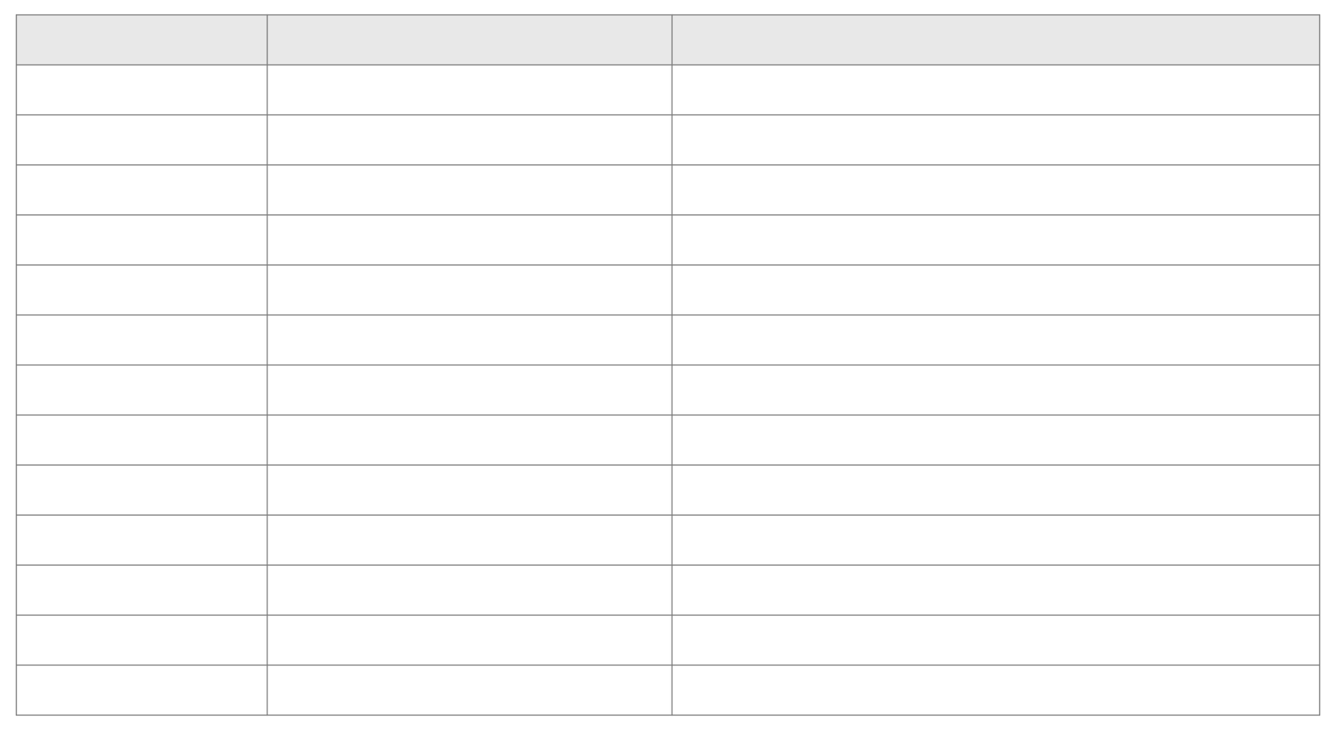
FORM FIELD DETAILS
Basic Field
Form
Field
Name
Purpose
Candidate Name: The Name field collects the candidate's first and last name. Example: Arjun Kumar.
Email Address: The Email field collects a valid email address for communication and interview update
Current Address: The Address field collects address line, city/district, state/province, postal code and country.
Contact Number: The Phone field collects the candidate's Indian mobile number.
LinkedIn Profile: The Single Line field stores a LinkedIn or portfolio URL.
Cover Letter: The Multi Line field allows candidates to explain why they are suitable for the role.
Years of Experience: The Number field records the candidate's experience. The configured range is 0 to 40.
Available Joining Date: The Date field records the earliest joining date and does not allow past dates.
Preferred Interview Time: The Time field records the candidate's preferred interview slot.
Department Applied For: The Drop Down field is used to select a department.
Employment Type: The Radio field provides Full-Time, Part-Time and Internship options.
Key Skills: The Multi Select field in this form provides only Java, SQL, Python and Communication.
Background Verification Consent: The Checkbox records the candidate's agreement and must be checked before submission.

SAMPLE RECORDS
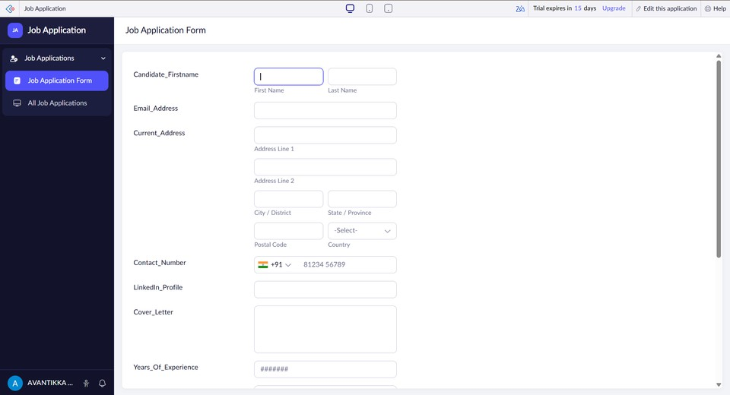
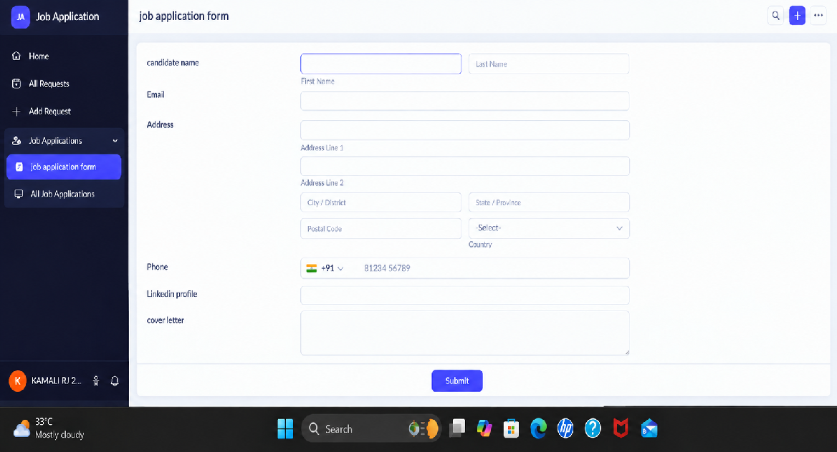
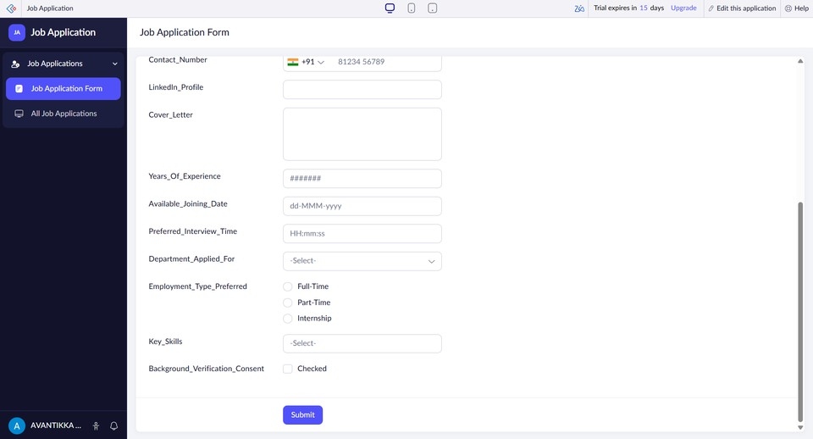
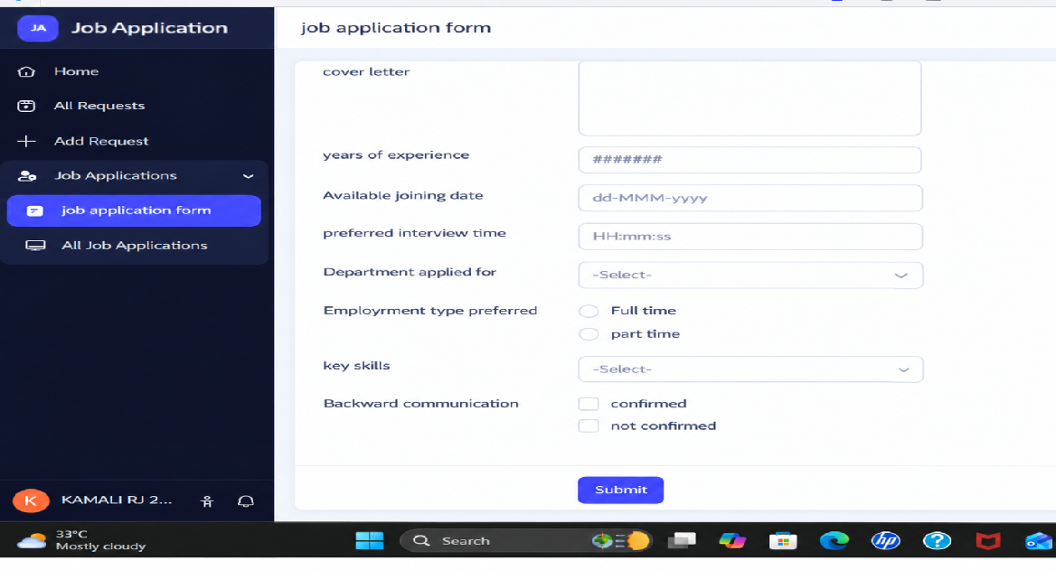

SAMPLE COVER LETTERS
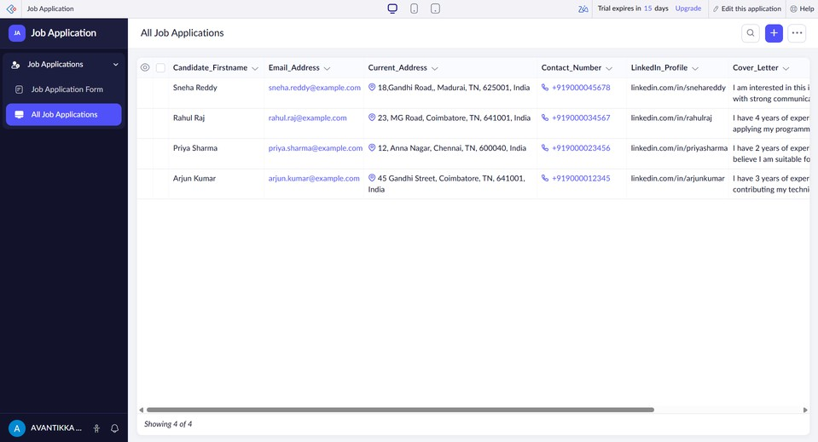
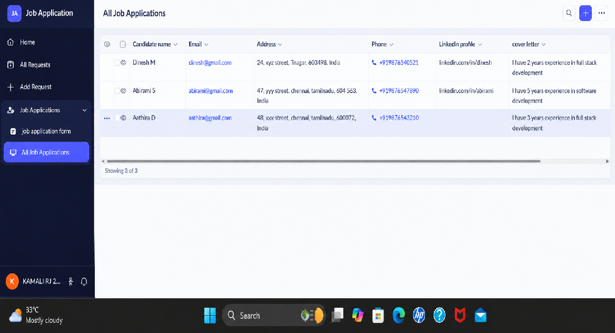

REPORT VIEW
A report named All Job Applications was created to display submitted candidate records. The report can be used to view candidate details and manage applications.

VALIDATIONS USED
  - Candidate Name, Email, Phone, Department, Employment Type and Consent are mandatory.
  - Email format validation is enabled.
  - Indian country code is used for phone numbers.
  - Years of Experience is restricted to 0–40.
  - Available Joining Date does not allow past dates.
  - Background Verification Consent must be checked before submission.

RESULT
The Job Application Form was successfully created using Zoho Creator. The form collects candidate details, job preferences, experience, skills, interview details, cover letter and background verification consent. The submitted applications are displayed in the All Job Applications report.

